**[F29DC 2024 Lab 1 - Connectivity, VPCs, Subnets, VLANs](https://canvas.hw.ac.uk/courses/28951/files/3694381?wrap=1" \o "F29DC 2024 Lab 1 - Connectivity, VPCs, Subnets, VLANs.pdf" \t "_blank)  
- Shyam Sundar Velmurugan  
- H00418621**  
  
{ Part 2 }   
Subnets   
  
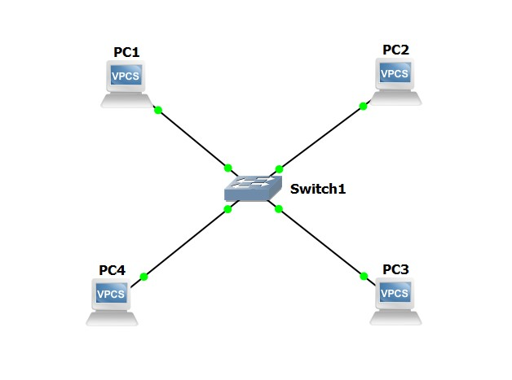  
Image 2.1: Adding two more VPCs PC3 and PC4.  
  
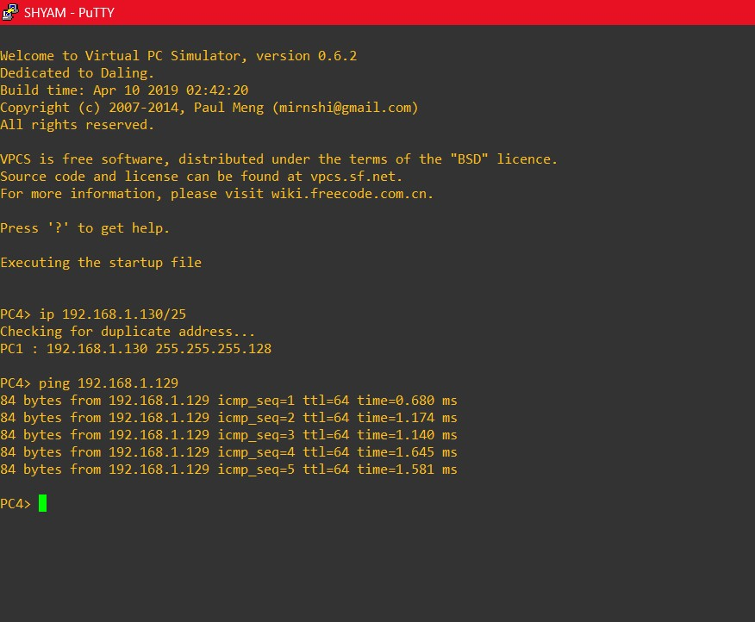   
Image 2.2: Providing IP address for PC4 and checking if it can ping PC3s IP address.  
  
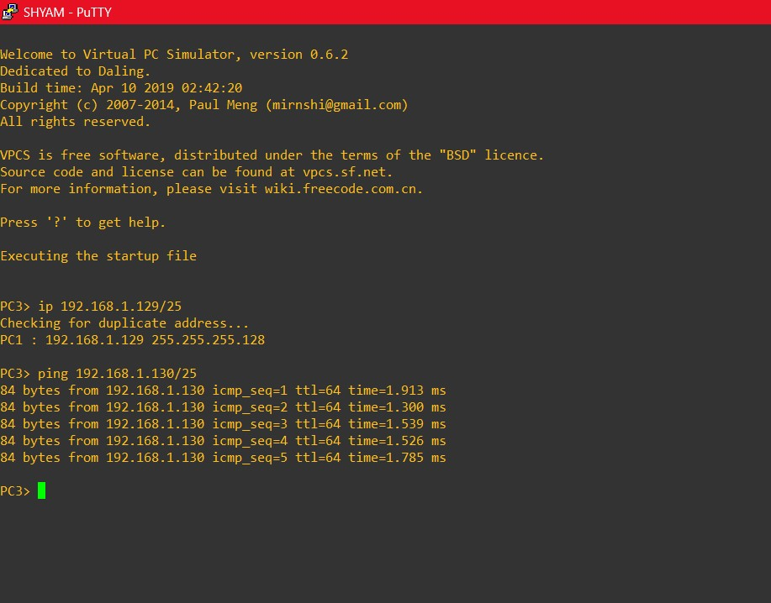  
Image 2.3: Providing IP address for PC3 and checking if it can ping PC4s IP address.   
  
  
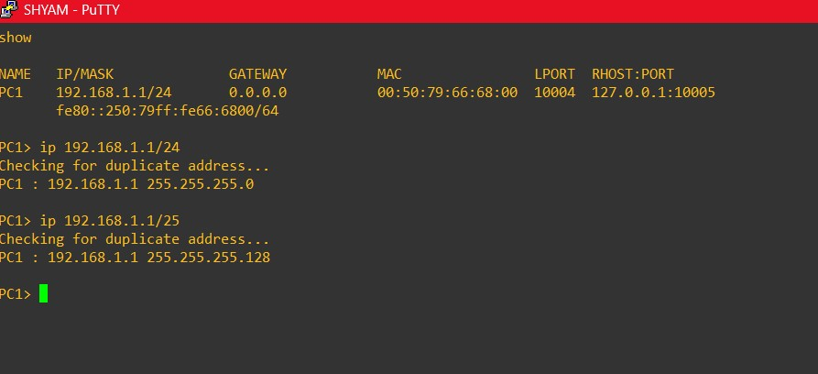  
Image 2.4: Changing the network mask of PC1 from 192.168.1.1/24 to 192.168.1.1/25.  
  
  
  
  
  
  
  
  
  
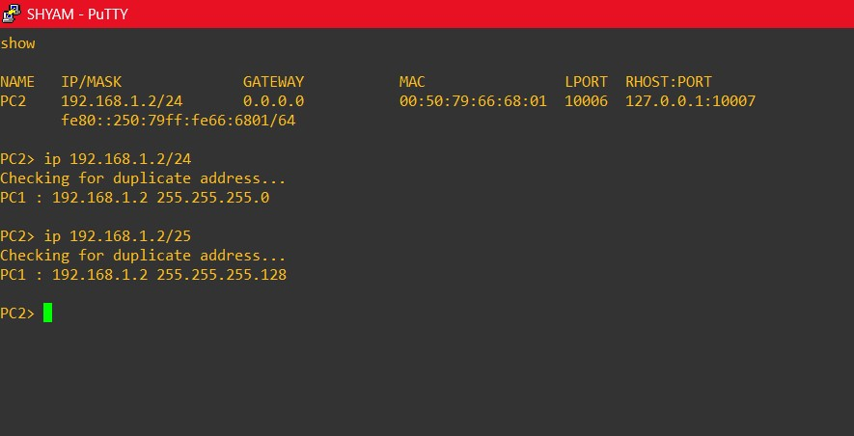  
Image 2.5: Changing the network mask of PC1 from 192.168.1.2/24 to 192.168.1.2/25.

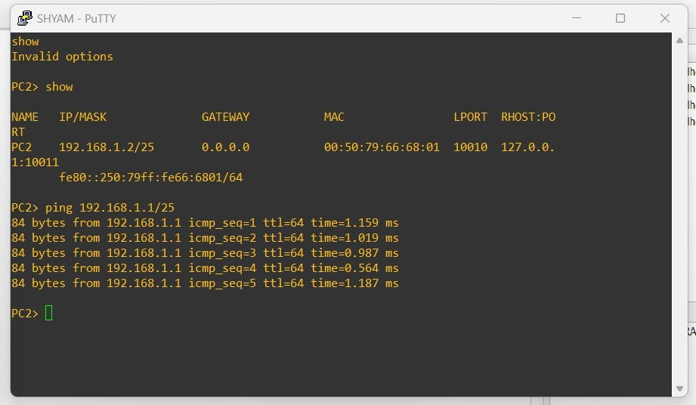   
Image 2.6: Checking if we can PC1 from PC2 after network masking changes.  
  
  
  
  
  
  
  
  
  
  
  
  
  
  
  
  
  
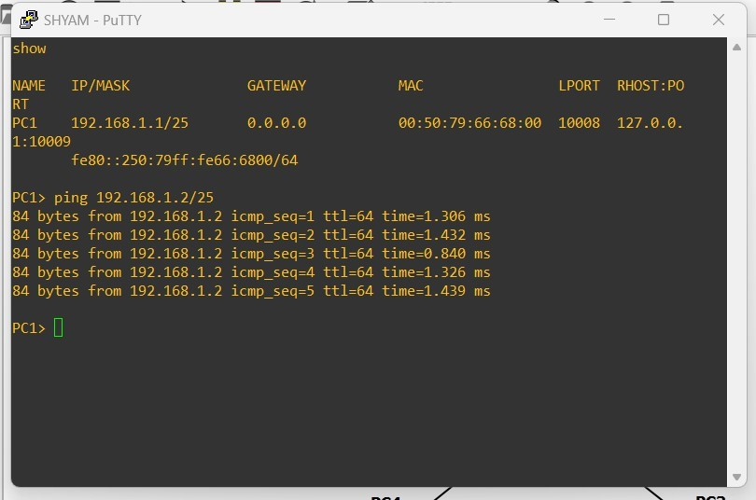  
Image 2.7: Checking if we can PC2 from PC1 after network masking changes.

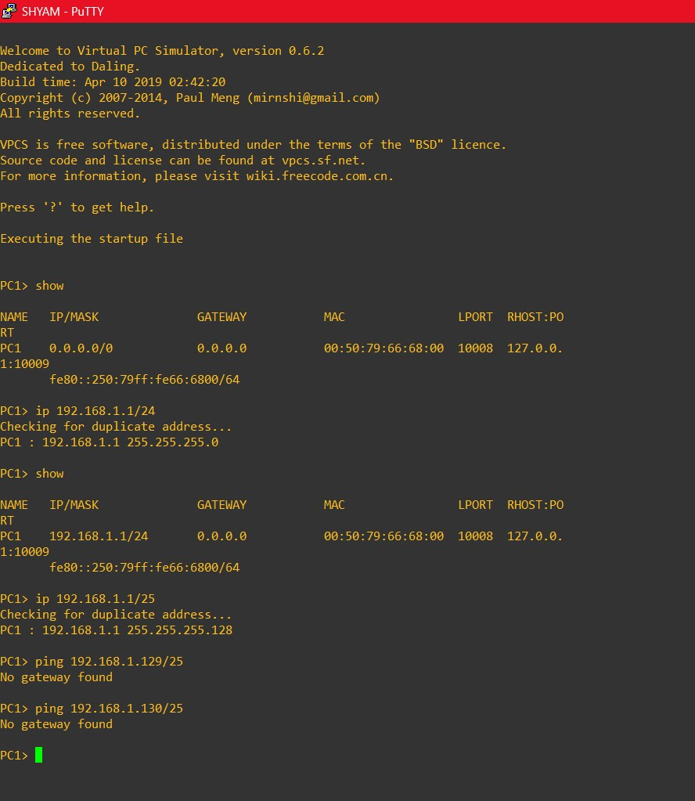  
Image 2.8: Checking if we can ping PC3 and PC4 from PC1 by providing the IP address.   
  
  
  
Conclusion:   
There was no gateway found between PC3 - PC1 and PC4 - PC1 as the subnets of PC1 and PC2 is different from PC3 and PC4.